Live Online and Phone Mindfulness Courses
These courses offered by MPA are run by a Mindfulness Teacher, just like the face to face ones, but instead of being in the same room, you join the course with a video link OR an audio link. Depending on the course. Some courses have options to do either.
MPA use the application Zoom as it is secure, allows stable audio and/or video and enables everyone to link in and listen to each other at the same time regardless of if they are on their computer or phone. Quality of the calls does depend on the internet reception and speed of both the facilitator and the participant.
Your Mindfulness Teacher will either text or email you a message with the details on how to link in for the session. There are lots of ways you can link in, you choose either:
- Linking in with your computer or tablet if you have a camera, microphone and speakers will enable you to see and hear everyone else in the group. Click on the link you are given by your facilitator or go to the website here https://zoom.us/join and enter the Meeting ID number that your facilitator will provide.
- If your computer doesn’t have a camera but does have a microphone and speakers, you will be able to hear everyone and they can hear you, but not see them. Use same link or login as above.
- If you use your iphone, there will be a link emailed to you by your facilitator that you can click on. If that doesn’t work, download the Zoom Cloud Meetings app from the app store and join a meeting using the meeting ID number that your facilitator will give you.
- If you have an android, there will be a link for computers or Androids to click on, or go to your app store and download the Zoom Cloud Meetings app and enter the meeting ID from your facilitator.
- If you would like to use your phone and call the phone number that the teacher sends you (costs just a local call each session), you will only have access to audio in the meeting. When you dial the phone number given, you’ll be asked to enter a meeting ID (identification) which is a number that the teacher will give you. It’s the same number each session. Follow this with the # key. There is no participant number, just press # and you’ll go straight to the meeting room.
If you have any problems you can message the Teacher in the chat function or text them. Your Teacher will adjust the program so that you don’t need to have visuals if you can’t access them.
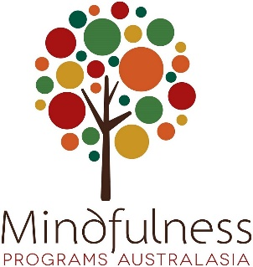
Thanks for participating in one of our programs!

